Discussion Topic: 1
Due March 22, 2020
Discussion Topic:
*Discuss the major ways in which the Iraq War (2003-2007) impacted the Balance of Payments (BOP) account of the United States – (Be sure to consider both the Current Account and Capital Account components of the BOP).
- [Discussion must be elaborate and well-written to earn full points -- minimum of 1 page (double-spaced) expected].

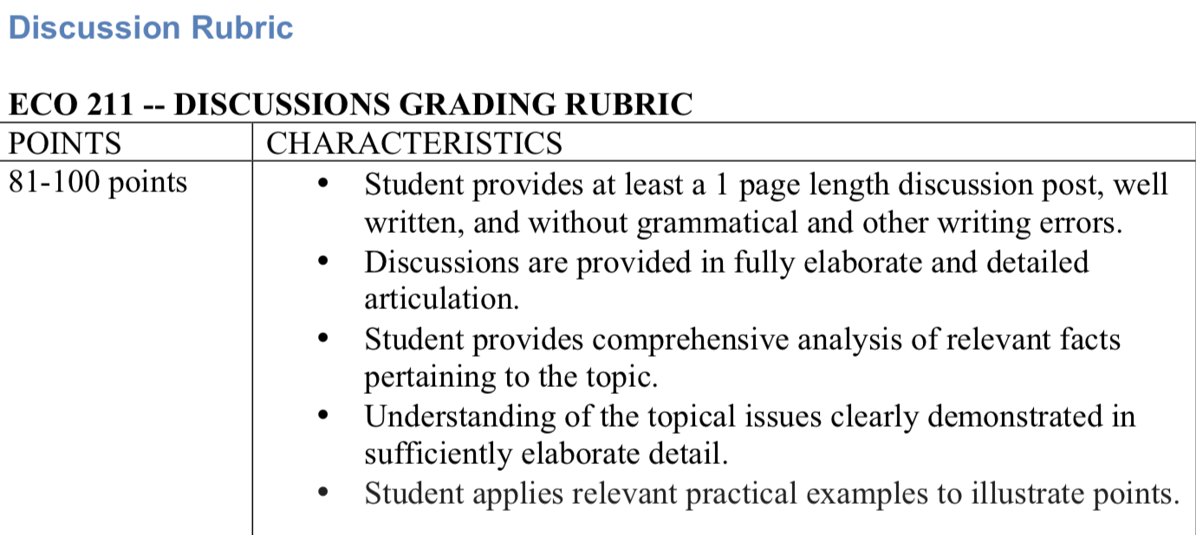

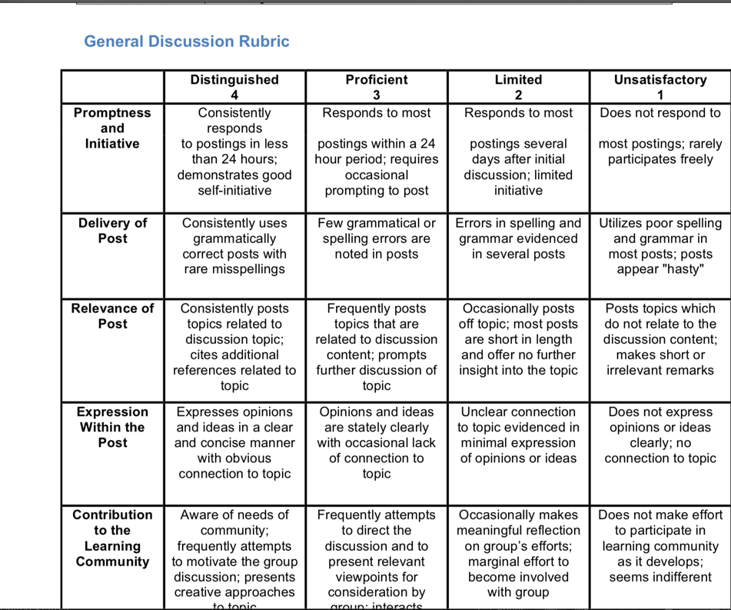

Score 100/100 sample essay

The United States is the world's largest economy. Moreover, it is the largest exporter and importer of goods and services. Trade is an essential part of America's prosperity. Trade fuels America’s economic growth, supports quality jobs at home, raises the living standard, and aids American citizens in providing for their families with affordable goods and services. It is clear that trade plays a vey large role in the economy, so it is vital that trade and its processes are well-managed and protected.
One way to protect trade and its impact is to carry out Trade Protectionism. Trade protectionism is the practice where countries restrict trade flows with one another; Trade protection is carried out by using various measures to restrict the flow of imports or exports of goods and services across countries. There are multiple forms of trade protectionist measures, and these measures are known as the “Instruments of Trade Production.” The main “Instruments of Trade Production” are trade embargo, trade quotas, trade tariff, subsidies, countervailing duties, and non-tariff barriers. The instrument of production that we will be focusing on today is trade tariffs and their positive and negative economic effects when the U.S. imposes them on importation of foreign goods.
Trade tariffs are the most commonly used protectionist measure; it is a tax imposed on goods imported into the country. Tariffs raise the prices of imported products, and yield a competitive edge to domestic producers. Though this method is common, it has both positive and negative economic effects on the U.S. economy.
Though some say that tariffs provide for a competitive edge to domestic producers, other argue that tariffs have demonstrated to cause more economic harm than benefit.
Two negative economic effects of imposing tariffs on importation of foreign goods, which would reduce the availability of goods and services for U.S. businesses and consumers is reduced employment and lower income/economic output. Tariffs have the opportunity to reduce U.S. output through a few channels. One possibility is that a tariff could pass on to producers and consumers in higher prices; Moreover, tariffs could raise the price of materials, and that would raise the price of goods utilizing those inputs and therefore reducing private sector output. This domino effect would resume by yielding lower incomes for both the owners of capital and the workers. To make matters worse, higher consumer prices would reduce the capital and labor income after-tax, and that would push Americans to work and invest less, which would lead to lower output. Despite those very impactful negative economic effects, there are a few positive economic effects that come out of trade tariffs.
Two positive economic effects are increased revenue and a reduction in competition. As imports enter the domestic market with the taxes imposed on them, the government will see a jump in revenue, which is a goal that all countries want to see. In partnership with an increase in revenue, domestic industries also benefit from a reduction in competition. This reduction in competition occurs because prices are artificially inflated and the availability of goods and services often lowers, so consumers purchase where they can. Overall, trade tariffs are utilized as a protective measure of America’s key to economic prosperity. These tariffs have the opportunity to be beneficial as well as harmful. Like anything in life, balance is a very important practice that should be carried out within the U.S. economy.
Overtaxing can lead to low employment opportunities and poor economic outputs, but can also increase revenue and decrease trade competition. Trade tariffs continue to be a very controversial topic, but will live on to serve as protectionist to America’s beloved craft of trade.

